JOIN
INNER JOIN
SELECT * FROM Orders
INNER JOIN Customers
ON Orders.CustomerID = Customers.CustomerID;

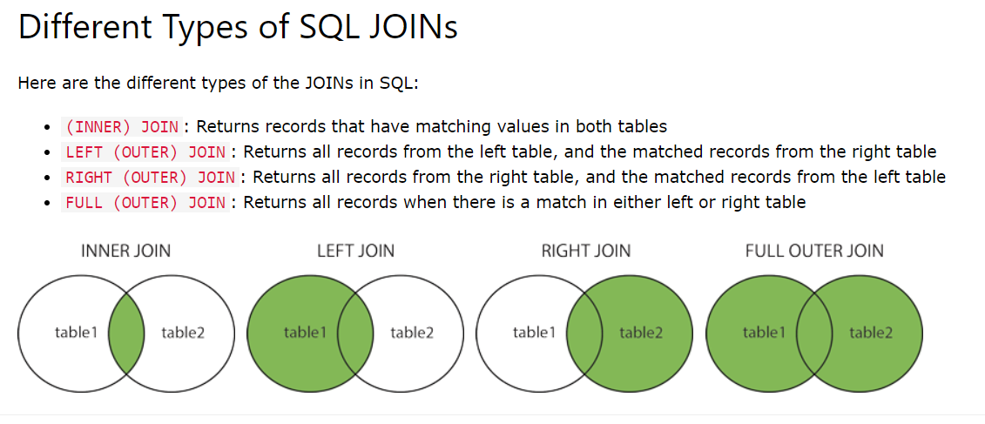

Join two table and then Group by
SELECT Shippers.ShipperName, COUNT(Orders.OrderID) AS NumberOfOrders
FROM Orders
LEFT JOIN Shippers ON Orders.ShipperID = Shippers.ShipperID
GROUP BY ShipperName;

DISTINCT
(Returns Unique Value or Different Value)
SELECT DISTINCT column1, column2, ... FROM table_name;

UNION
SELECT Country FROM Employees
UNION ALL
SELECT 'Unknown' AS Country

